Classful IP Addressing

Introduction
An IP address is a unique 32-bit number assigned to devices on a network. In IPv4, this address ensures each device can be identified and communicated with correctly.

Overview of Classful Addressing
Classful addressing was the original scheme for IPv4 address distribution from 1981 to 1993. It divided the address space into five classes (A, B, C, D, E). This system was later replaced by CIDR for greater efficiency.

IPv4 Address Format
- Written in dotted decimal (e.g., 192.168.1.1)
- Each octet ranges from 0–255
- Also used in hexadecimal notation

Need for Classful Addressing
- Made address assignment and identification easier
- Simplified routing in early network equipment
- Helped expand the early Internet

Details of Each Class
- Class A: For large organizations needing many devices
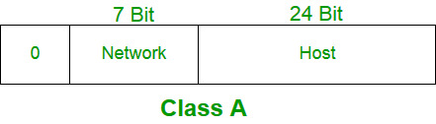
- Class B: For mid-sized organizations or ISPs
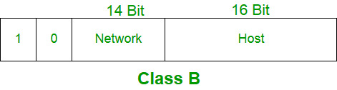
- Class C: For small networks, often homes or small businesses
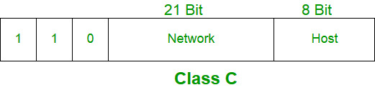

- Class D: Reserved for multicast groups
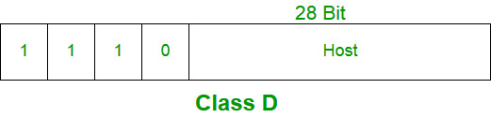

- Class E: Reserved for experimental purposes
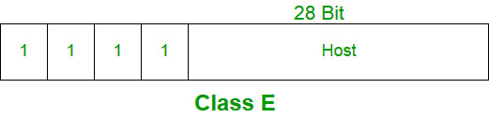

Overview
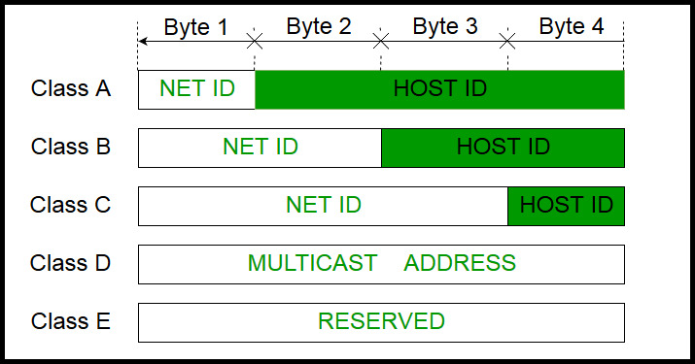

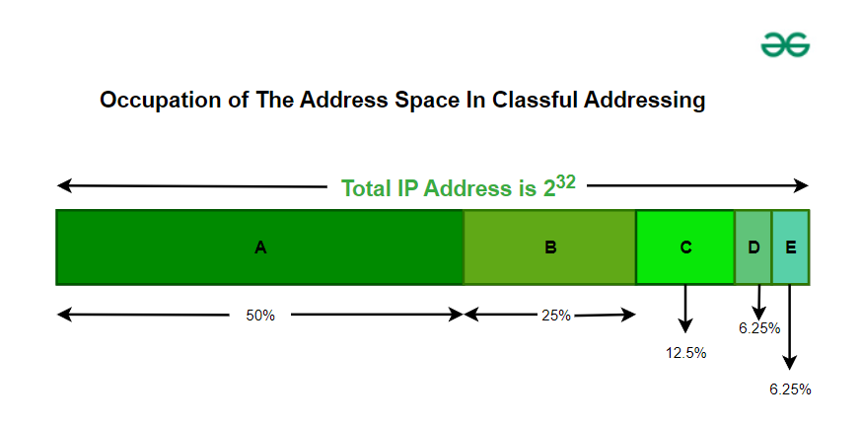
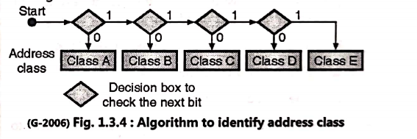

Special Address Ranges
- 169.254.0.0 – 169.254.255.255: Link-local addresses
- 127.0.0.0 – 127.255.255.255: Loopback addresses
- 0.0.0.0: Used for local network communication or default routing

Rules for Assigning IDs
- The host ID must be unique on each network.
- All host bits set to 0 define the network address.
- All host bits set to 1 define the broadcast address.
- Network IDs cannot start with 127 (reserved for loopback).

Problems With Classful Addressing
- Inefficient: Many addresses wasted, especially in Classes A and B
- Not scalable for organizations with needs between class sizes
- Class D/E were not usable for regular devices

